# Analysis and Design Unit – Evidence

## **David Ellis**

## **Cohort E18**

## A.D. 1 – Use Case Diagram

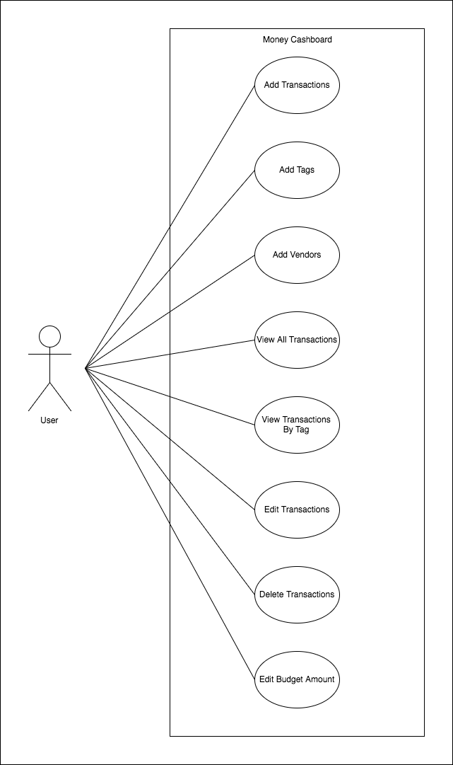

## A.D. 2 – Class Diagram

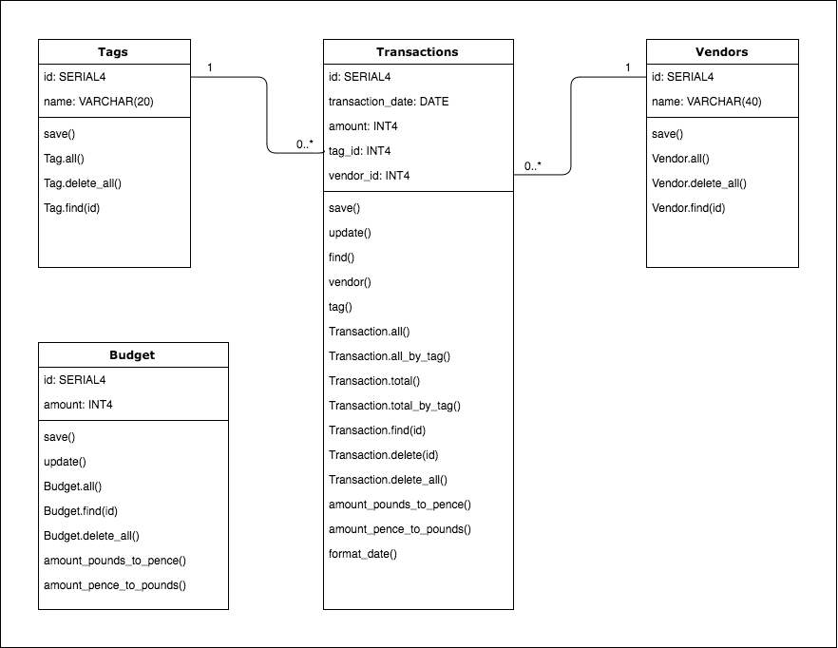

## A.D. 3 – Object Diagram



## A.D. 4 – Activity Diagram



## A.D. 5 – Inheritance Diagram *W9

## A.D. 6 Implementation Constraint Plan *W5